Hinge Questions:
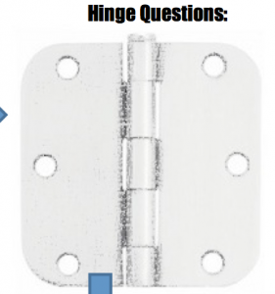
A good hinge question has 4 answers: a ‘right right’ answer, a right answer, an ‘almost right’ answer and a wrong answer. Ask students to write their answer down in secret to avoid negative peer influence. Be prepared to intervene, change direction, rearrange the students and your lesson in light of the response to the hinge question. You are testing what they have learned and using it to inform your teaching. After the hinge question you will regroup students, ask students in the ‘right right’ group to help those in the ‘almost right’ group, invite peer teaching, let some groups work independently and others work intensively with you.

Targets with an emotional kick:
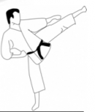
Connect the formative targets in the classroom to the bigger picture and the student’s wider ambitions. Emotionally connected targets are pursued more enthusiastically. Targets written for students on a Sunday night are virtually useless and ignored. Targets work when students agree them; own them and are connected with them.
- What is really driving the students’ pursuit of their targets?
- Family expectations?
- Personal ambition?
- Greed?
- To change the world?

Feedback:
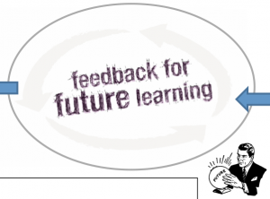
Great feedback is a conversation not a monologue. Who starts the marking conversation and when is it started? To initiate a marking conversation invite students to mark your marking: they will use a ‘tick’ to say – “I understand and agree with your marking”; a ‘cross’ to say, “I don’t agree” (and then they give their reasons); and a ‘question mark’ to say, “I don’t understand the comments”.
Many marking conversations start in the lesson and need to be held and recorded. How are you going to capture these conversations? Digitally with a visualizer? A Wiki or as an audio recording? Analogue methods include using paper wristbands, a Negotiated Assessment Grid (NAG) or a marking/feedback diary.

Self-reflection:
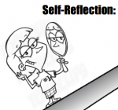
Structure self-reflection using three simple questions. Give the students 2 minutes to answer each one with an exhaustive list. The ritual of structured self-reflection improves students’ ability to recall their input and involvement. If you don’t teach students a ritual and structure for self-reflection, they will improvise their way through it, badly. Try these headings:
- What have I given to the task/group/class?
- What knowledge/understanding/skills have I taken away?
- What troubles have I caused?

Moments of transfer:

When do you transfer the responsibility for the learning to the students? What techniques do you use? Lowering your status by sitting on the floor and scribing while students sit on chairs and suggest success criteria for the task; showing students the quality/breadth/ambition of their own ideas by posting them on the wall and asking them ‘Whose ideas are these?’; using check-lists or grids of criteria positioned next to the students while they are working; asking students to lead sections of the lesson?
When you persistently transfer responsibility for the learning to the students and make it clear that they are driving progress, then progress accelerates.

Final template:
Here is what The 5 Minute AfL Plan by @PivotalPaul & @TeacherToolkit looks like:
